Income and Liquor Spending Behavior Across Iowa Counties: A Data-Driven Policy Analysis

ADEC 7900: Course Project Final Report
Prepared by: Shreyansh Budhia, William Brewster, and Ramzi Nia

1. Introduction
The analysis was conducted for the Director of Health & Human Services for the state of Iowa, which serves as the states agency overseeing assistance programs, Medicaid, health & prevention initiatives. These organizations operate in a decision environment that balances economic revenue generation, public health concerns, and community well-being. Liquor sales represent a major source of state revenue, but alcohol consumption is also associated with long-term public health and social costs.
The broader decision climate is influenced by:
- Rising healthcare expenditures,
- Public concerns over substance abuse,
- And debates over how alcohol access and taxation should be structured across income groups and geographic regions.

Research Question
Is there a meaningful relationship between median household income and liquor spending per capita across Iowa counties?

Policy Relevance
Understanding whether higher-income counties consume more alcohol on a per-person basis helps decision makers:
- Evaluate the equity of alcohol taxation policies,
- Identify whether alcohol consumption burdens fall disproportionately on certain income groups,
- And determine where education, prevention, or regulatory resources should be targeted.
Policy decisions based on this analysis affect:
- State revenue collection,
- Public health planning,
- And long-term community outcomes related to alcohol misuse.

2. Data Summary
This study integrates two primary datasets covering all 99 Iowa counties. The liquor sales dataset (2020) reports total sales revenue, product category, and sales volume at the county level. The American Community Survey dataset (2019) provides median household income and population by county. The final merged dataset contains observations for all 99 counties.
Each observation represents aggregated sales for a specific product category within a county. Because counties vary widely in population size, direct comparison of total sales alone would introduce population bias.

Liquor Sales Dataset (2020)
This dataset contains county-level liquor sales information broken down by product category. Key variables include:
- 990 transaction-level observations
- Key fields:
  - County
  - sale.dollars
  - sale.volume
  - category

American Community Survey Dataset (2019)
The ACS dataset provides socioeconomic indicators at the county level. Variables used include:
- 99 Iowa counties
- Key fields:
  - income (median household income)
  - population
  - Education, unemployment, and demographic population shares

Table 1. Core Descriptive Statistics for Key Variables
Variable | Mean | Median | Minimum | Maximum
Median Household Income ($) | 29,981.98 | 30,253.50 | 18,959.00 | 43,120.00
Population | 31,556.47 | 15,606.50 | 3,822.00 | 459,159.00
Total Liquor Sales ($) | 2,680,881.68 | 782,309.50 | 25,053.00 | 61,059,636.00
Liquor Dollars Per Capita ($) | 58.50 | 55.61 | 3.57 | 220.83

Table 2. Distribution Detail (10th, 25th, 75th, 90th Percentiles)
Variable | 10% | 25% | Median | 75% | 90%
Income ($) | 26,692.00 | 27,907.75 | 30,253.50 | 31,374.00 | 33,219.00
Population | 7,365.00 | 10,084.00 | 15,606.50 | 24,894.75 | 57,141.20
Sales ($) | 207,934.70 | 443,400.25 | 782,309.50 | 1,651,912.00 | 4,279,618.80
Per Capita ($) | 25.22 | 36.62 | 55.61 | 71.08 | 95.36

Methodological Implications
Because the two datasets come from different sources and different years:
- We assumed relative short-term income stability between 2019 and 2020.
- We transformed total liquor sales into per-capita values to ensure fair comparisons.
- An inner join by county ensured consistent geographic alignment.

Descriptive Summary
Across Iowa counties:
- Median household incomes show clear regional variation.
- Population ranges from small rural counties to large urban counties.
- Liquor sales totals vary substantially, largely driven by population size before normalization.

3. Data Analytics

SQL Aggregation & Validation
SQL was used to:
- Aggregate transaction-level sales into county-level totals
- Join sales with county income and population
- Validate completeness and remove inconsistent county labels
Core SQL structure:
- SUM(sale_dollars) grouped by county
- INNER JOIN with ACS county income and population
This provided:
- Total liquor sales by county
- Verified county-level joins
- A reproducible aggregation pipeline for auditing

Aggregation and Feature Engineering
We first aggregated liquor sales at the county level:
$$\text{Total County Liquor Sales}=∑\text{sale.dollars}$$
We then constructed a per-capita spending variable:
$$\text{Liquor Dollars Per Capita}=\frac{\text{Total County Liquor Sales}}{\text{Population}}$$
This transformation was essential to remove population-driven distortion.

Merging Process
The sales and ACS datasets were merged by county using:
- SQL for initial validation,
- R for data cleaning and aggregation,
- Python for final analysis, correlation testing, and visualization.
All three tools produced consistent numerical results, confirming the reliability of the workflow.

Correlation Analysis
We computed the Pearson correlation coefficient between:
- Median household income
- Liquor dollars per capita

Final Result

SQL was used for initial data validation, county-level aggregation, and verification of summary measures. Python and R were used for per-capita normalization and correlation estimation, while Tableau supported final interactive visualizations.

The Pearson correlation between median household income and liquor spending per capita is r ≈ -0.106, indicating an extremely weak and slightly negative relationship. Per-capita liquor spending ranges from $3.57 at the lower end of the distribution to $220.83 in the highest-spending counties.

Total county-level liquor sales vary from approximately $25,053 to more than $61,059,636 annually, demonstrating that market size dominates total revenue patterns.

Interpretation
This value indicates:
- A very weak negative relationship
- Income explains almost none of the variation in liquor spending per capita
- Higher-income counties do not appear to consume more liquor per person
- Consitent coefficient using R and Python
The sign of the correlation suggests a slight tendency for lower-income counties to spend marginally more on liquor per capita, but the magnitude is too small to imply a strong behavioral pattern.

Visualization Insights
Figure 1. Median Household Income vs Liquor Spending Per Capita (Tableau Scatter Plot)
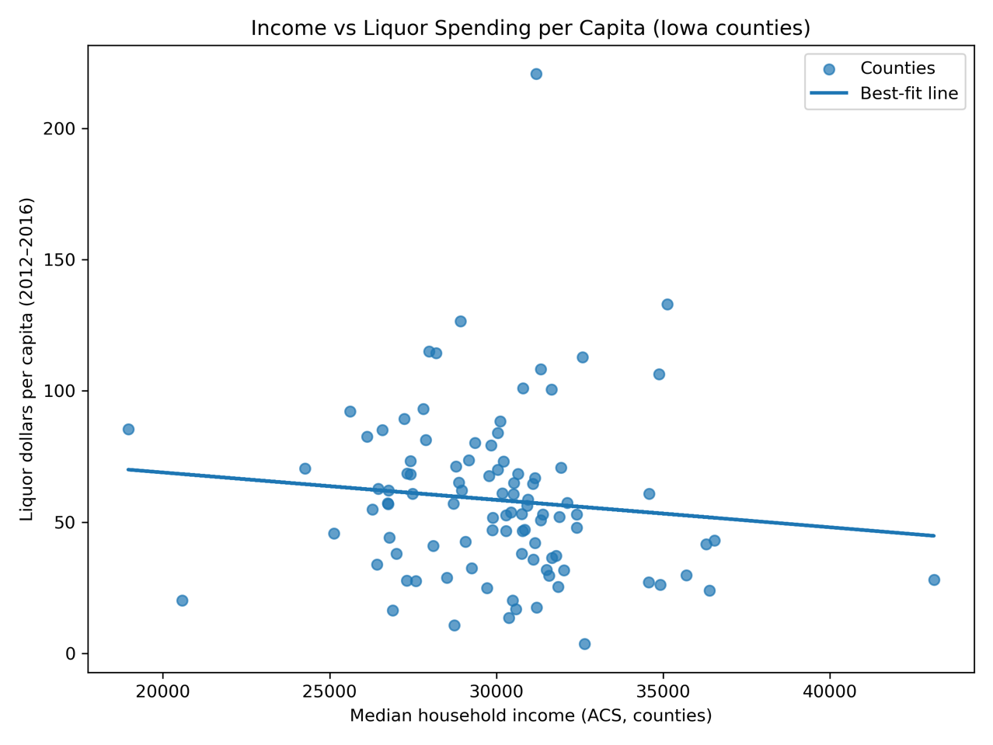
• Points appear near-randomly dispersed
• Regression line slopes slightly downward
• Confirms weak negative relationship (r ≈ –0.106)
This figure visualizes the relationship between county-level median household income and per-capita liquor spending. Each point represents a county, with values normalized by population to reflect individual-level consumption rather than total revenue. The scatter plot shows a widely dispersed pattern with no strong linear clustering. The estimated correlation coefficient (r ≈ −0.106) indicates a very weak negative relationship, suggesting that higher-income counties do not spend more on liquor on a per-capita basis. This result implies that liquor consumption behavior in Iowa is largely independent of income once population effects are removed.

Figure 2. Income vs Total Liquor Sales (SQL Output Visualization) –
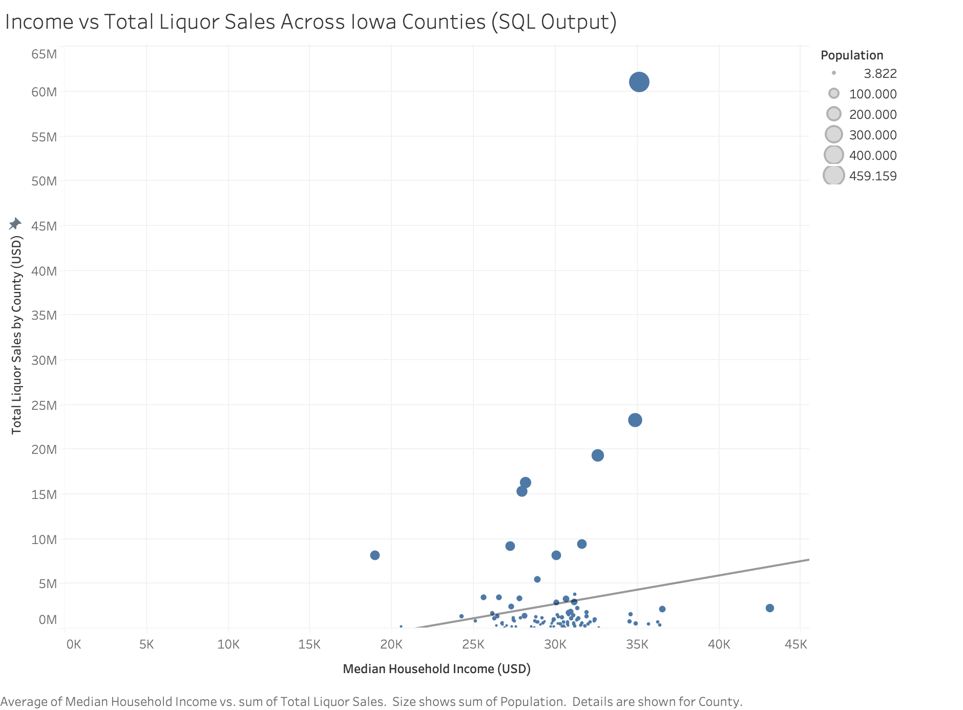
Strong upward slope appears here, but this is:
- Entirely driven by population size
- Not by individual consumption behavior
This visualization displays the relationship between median household income and total county-level liquor sales. While a positive association is visible, this pattern is driven primarily by county population size rather than differences in individual consumption behavior. Although the Income vs Total Liquor Sales visualization suggests a positive relationship, subsequent per-capita normalization reveals that this pattern is driven by population concentration rather than income-based differences in purchasing behavior
All these visuals reinforce the conclusion that:
Liquor consumption behavior in Iowa does not scale predictably with income.

Suggested Analytic Extension (Excursion)
A meaningful next extension would be to:
- Decompose liquor spending by product type (beer, wine, spirits),
- Control for urbanization, tourism, and age distribution,
- And apply panel data across multiple years.
These additional variables would allow for causal modeling rather than simple correlation.

Advantages & Challenges of the Software Tools
Tool | Advantages | Challenges
SQL | Excellent for large-scale aggregation and joins | Limited visualization, less flexible transformation
R | Powerful statistical tools and good for cleaning data | Requires scripting fluency
Python | Best balance of modeling, automation, and visualization | File path management and environments can be complex
Using all three tools allowed us to:
- Cross-validate results,
- Leverage each platform’s strengths,
- And improve overall methodological robustness.

4. Conclusion
This project applied a full analytical pipeline:
- Data ingestion and aggregation
- Normalization through per-capita transformation
- Correlation testing
- Visualization and interpretation
- Cross-platform validation

Final Answer to the Research Question
Median household income is not a meaningful predictor of liquor spending per capita across Iowa counties.
While small statistical noise exists, there is no economically significant relationship between income and individual liquor consumption at the county level.

Limitations
- Single-year analysis
- No behavioral controls (age, tourism, density)
- No causal inference
- County-level averages mask within-county inequality

Recommended Future Work
- Multi-year panel analysis
- Product-specific consumption modeling
- Incorporation of public health outcomes
During our initial SQL-based analysis, we observed a positive relationship between median household income and total liquor sales at the county level. This result reflects the fact that higher-income counties also tend to have larger populations, greater commercial density, and higher overall transaction volume. As a result, these counties naturally generate more total liquor revenue.
However, when we normalized sales by population in Python and R to compute liquor spending on a per-capita basis, this positive relationship disappeared. The per-capita correlation between income and liquor spending was approximately –0.106, indicating a very weak and slightly negative relationship.
This difference is not a contradiction but rather a change in the underlying unit of analysis. Total sales capture market size effects, while per-capita spending captures individual consumption behavior. Together, these findings suggest that while higher-income counties produce more total liquor revenue, higher-income individuals do not consume meaningfully more liquor than lower-income individuals.

5. Policy Recommendation

Policy Decision Facing the State
The decision maker is evaluating whether to:
- Adjust alcohol taxes based on income distribution, or
- Implement targeted prevention programs in specific counties.

Data-Driven Recommendation
Because income is not strongly linked to liquor consumption per capita, we recommend:
Targeting alcohol policy interventions based on consumption intensity and public health risk rather than income levels alone.
This suggests:
- Taxation policy should remain uniform rather than income-adjusted
- Prevention resources should focus on high per-capita consumption counties, regardless of income

First-Order Effects
- More efficient allocation of prevention funding
- Reduced misclassification of high-risk counties
- More equitable regulatory enforcement

Second-Order Effects
- Lower long-term healthcare costs
- Reduced alcohol-related crime and injuries
- Improved workforce productivity

Benefits
- Evidence-based targeting
- Reduced waste in public spending
- Improved health outcomes in high-risk regions

Risks
- Public resistance if high-consumption counties feel singled out
- Short-term revenue volatility in affected counties
These risks can be mitigated through:
- Transparent data communication
- Gradual implementation
- Community-based education programs

